Personal details
Please ensure all sections of this form are completed in full
Title |  |  |  |  |  | NHS number
Surname |  |  |  |  | Gender
First name |  |  |  |  |  | Occupation
Preferred name |  |  |  |  |  | Ethnicity
Date of birth |  |  |  |  |  | Religion
Address |  |  |  |  |  | Language
 |  |  |  |  |  | Consent for SMS Text Appointments to be sent
Post Code
Daytime Tel |  |  |  |  |  | Can patient/carer communicate by Telephone?
Emergency Tel |  |  |  |  |  | Emergency Contact name
GP name
GP Practice address or code
Please tick applicable boxes
Hearing impairment |  |  |  | Visual impairment
Pacemaker |  |  |  | Interpreter needed

Referral information details

Please give a brief description of why you would like a Physiotherapy assessment and how your problem is affecting you?

Please note that the Physiotherapist will only address one problem at your assessment, you can discuss with the therapist if you require further sessions.
How long have you had this problem?
Have you had any previous treatment for this problem? YES / NO When?
Are the symptoms worsening? Yes □ No□ N/A□
Are you able to carry out your normal activities? Yes□ No□ N/A□
Are you off work/unable to care for a dependent because of this problem? Yes□ No□ N/A□
Please list any medication you are taking and how many painkillers a day?

Please tell us of any existing medical conditions/ health problems you have

Can you mark on the body chart where you are getting the pain / problem?
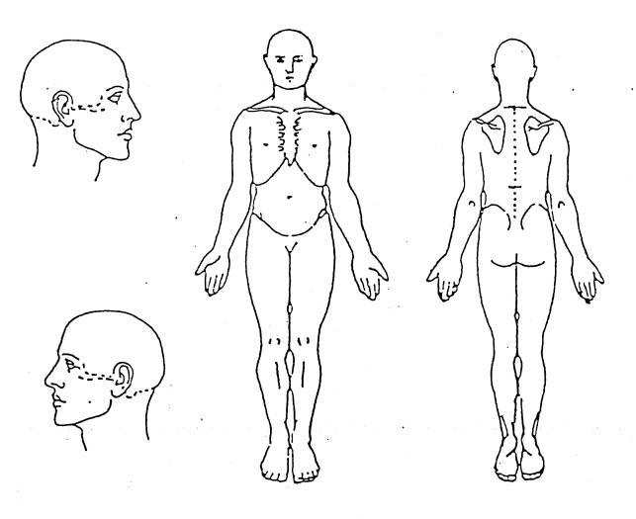
Have you had any other symptoms such as tingling/numbness/muscle weakness?
Please mark on body chart above.
Using a scale of 0 to 10, score your average level of pain, where 0 is no pain and 10 is the worst possible pain
0 1 2 3 4 5 6 7 8 9 10

If you experience any of the following, you need to seek attention via A&E
Numbness and/or altered sensation such as pins and needles around your back passage or genitals, e.g. when wiping after toileting. Sudden change with passing or controlling urine

If you experience any of the following, you need to speak to your doctor as soon as possible
Generally feeling unwell /night pain that does not settle with moving position
Back pain that starts when you have other problems, such as rheumatoid arthritis or cancer
Weakness in one or both legs that has not improved after one week/unsteadiness when you walk

Signature _________________________________ Date: ____________________

Please return to:
AHP Central Appointments
1st Floor Education Building
Bishop Auckland General Hospital
Cockton Hill Road, Bishop Auckland
Co Durham. DL14 6AD
Tel: 01388 455 200 Email: cdda-tr.centralbooking@nhs.net

